**Project Report**

Name: Sai Murali Krishna Jayam

Roll No: IMT2020035

1. **Use Case Diagram**

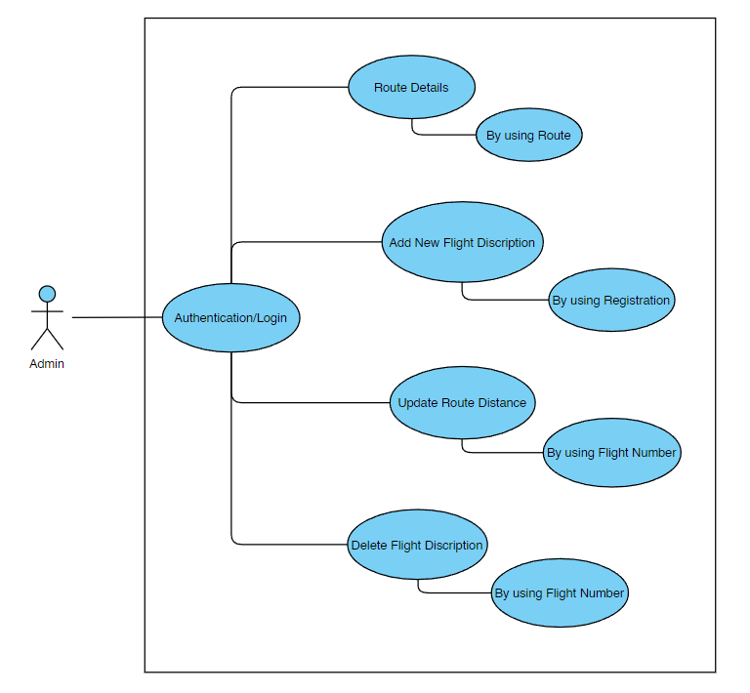

1. 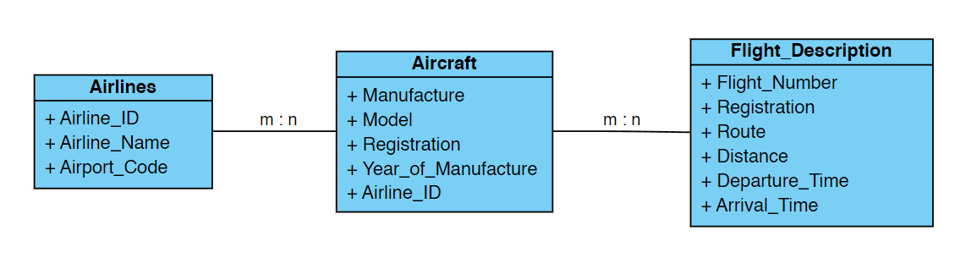**UML Diagram**
2. **OR Mapping(Database Design)**

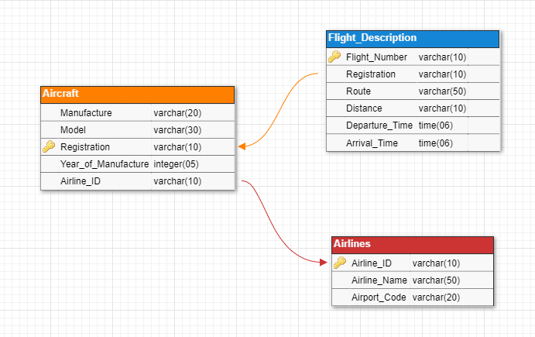

1. **Output Screenshots**

Authentication/Login

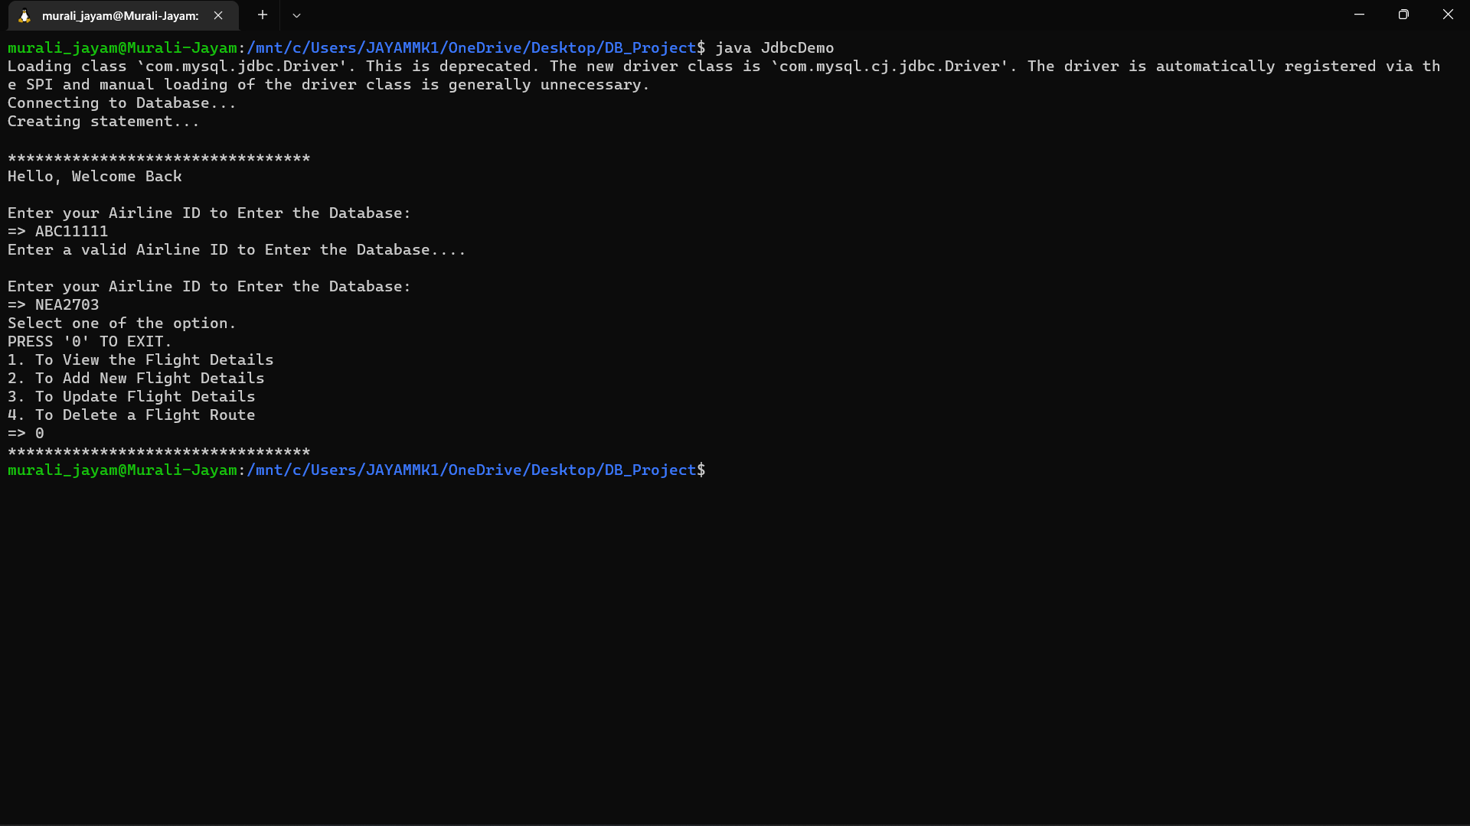

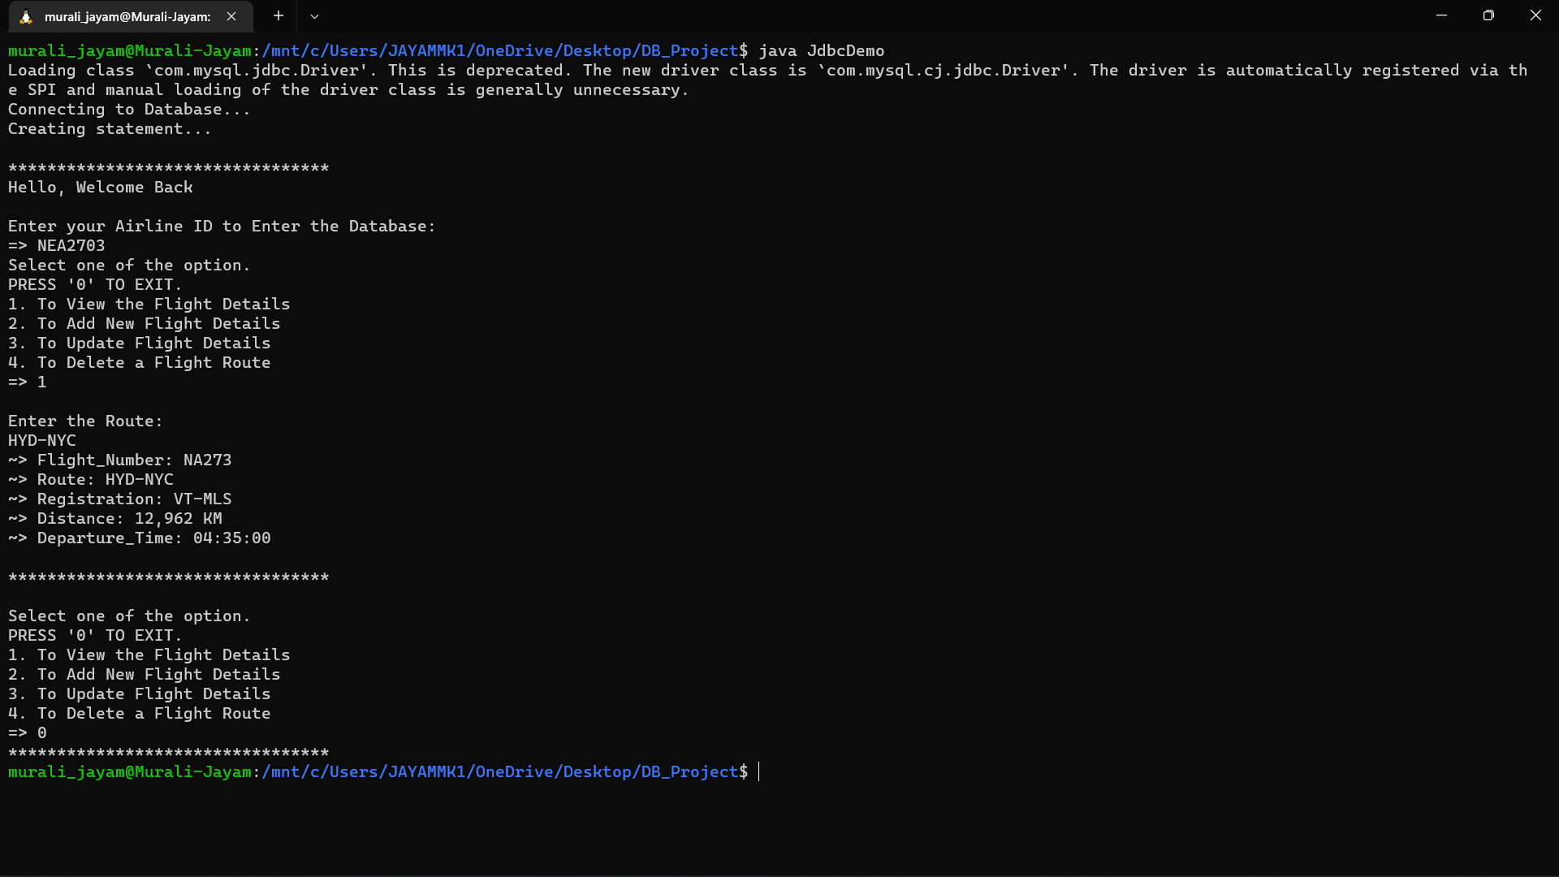Route Details

Add New Flight Description

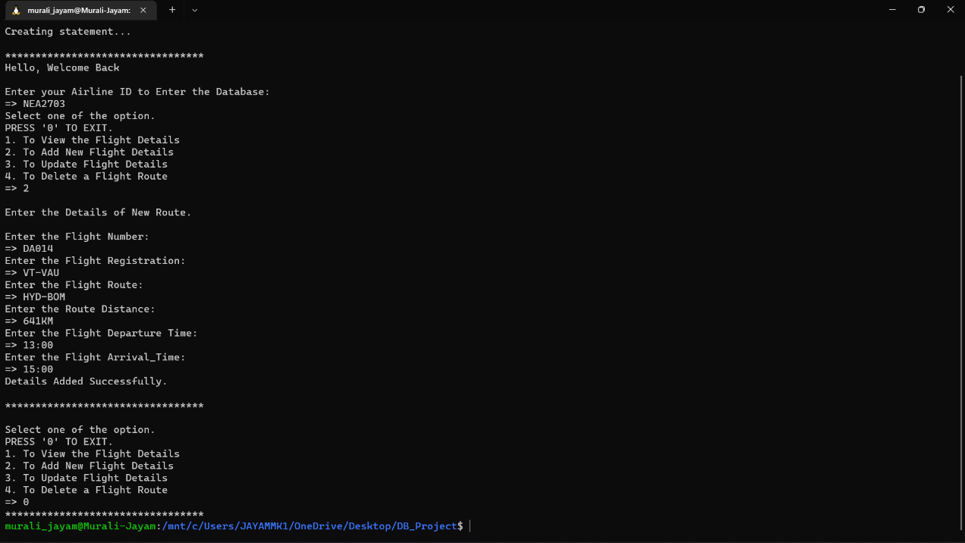

Update Route Distance

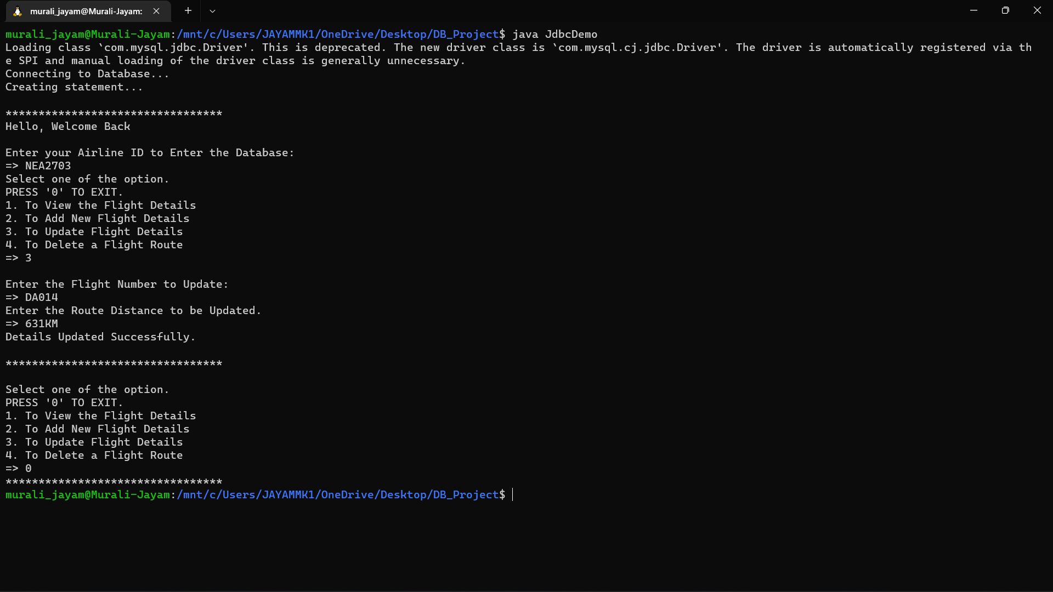

Delete Flight Description

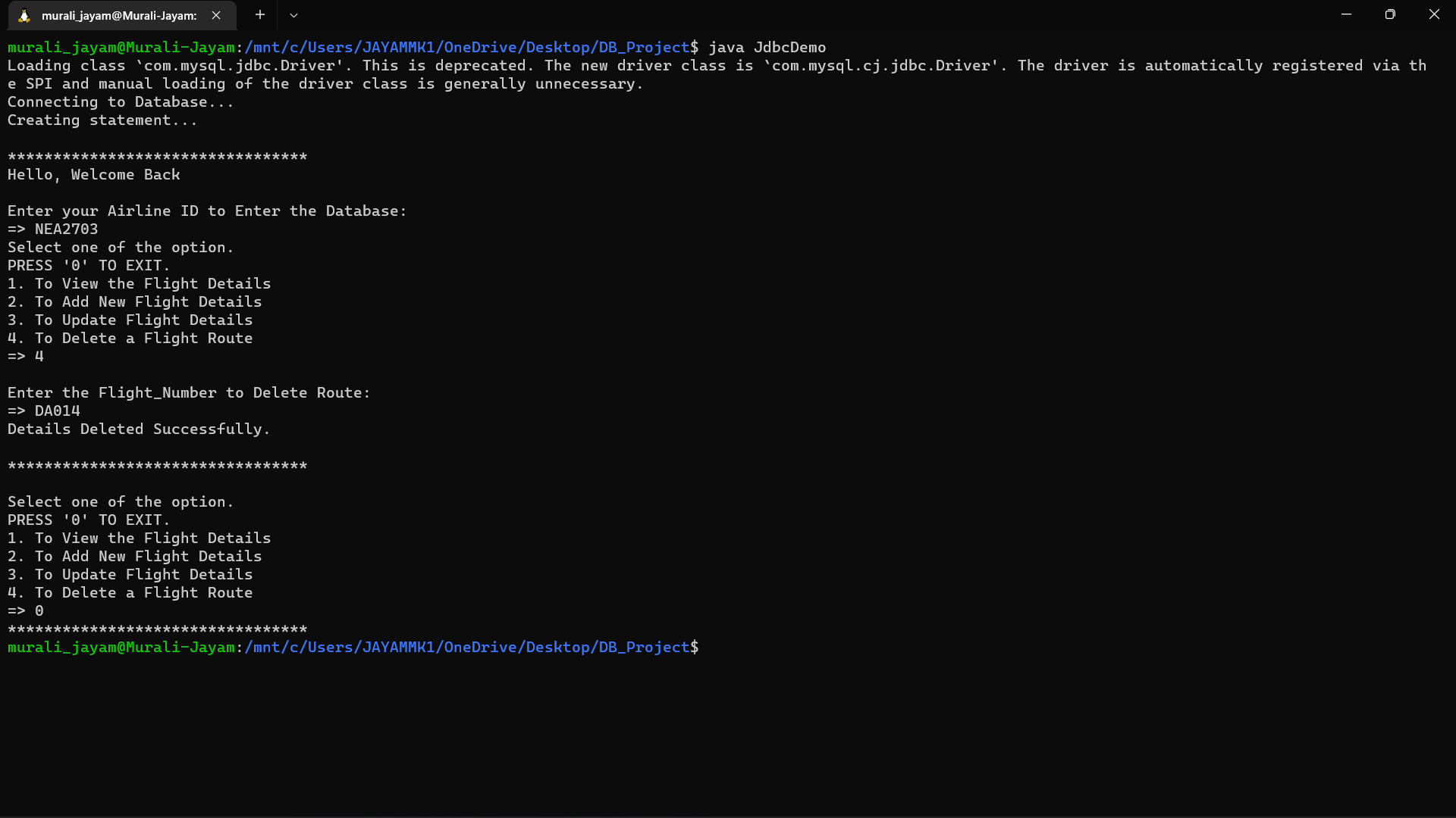

1. **Notes & Instructions to run the code**
2. Login to MySQL using (**mysql -u root -p**).
3. Run (**Create.sql**) to create tables.

Run (**Airlines.sql, Aircraft.sql, Flight_Description.sql**) to insert data into tables.

Use (**source path_of_file;**) to run the files.

1. Run (**export CLASSPATH='/mnt/c/Users/JAYAMMK1/OneDrive/Desktop/DB_Project/mysql-connector-java-8.0.18.jar:.'**) in Linux terminal to form the connection between java and mysql.
2. Run (**javac JdbcDemo.java**) to compile the code.

Run (java JdbcDemo) to execute the code.

1. Enter a valid Airline_ID to login and choose operation to run.